I made VPC and 3 subnets — customer subnet, FW subnet, IGW subnet
and associated firewall to them.
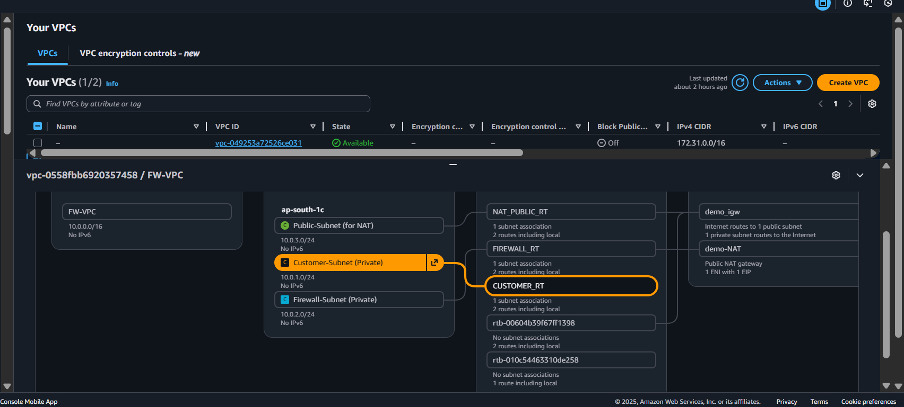
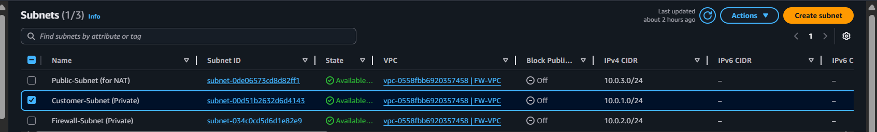
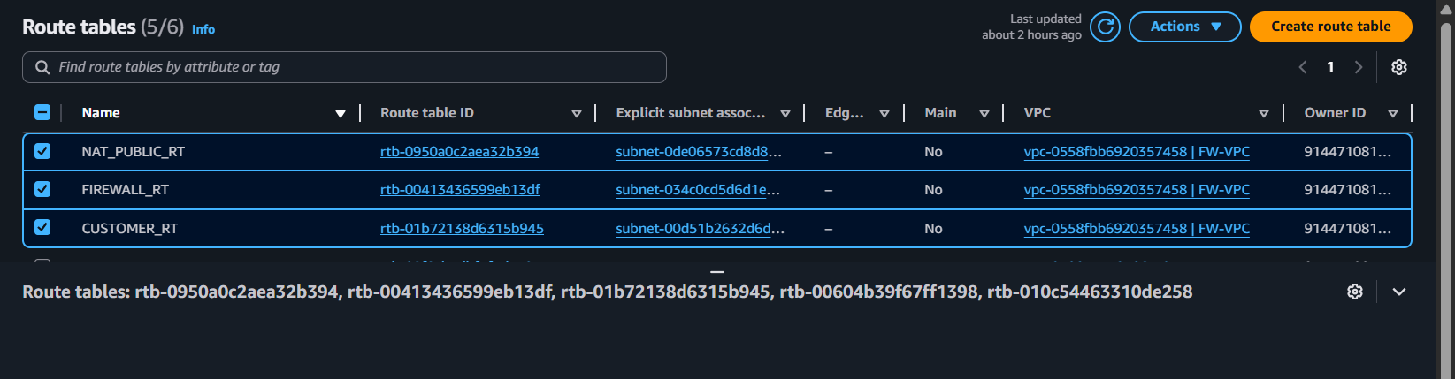
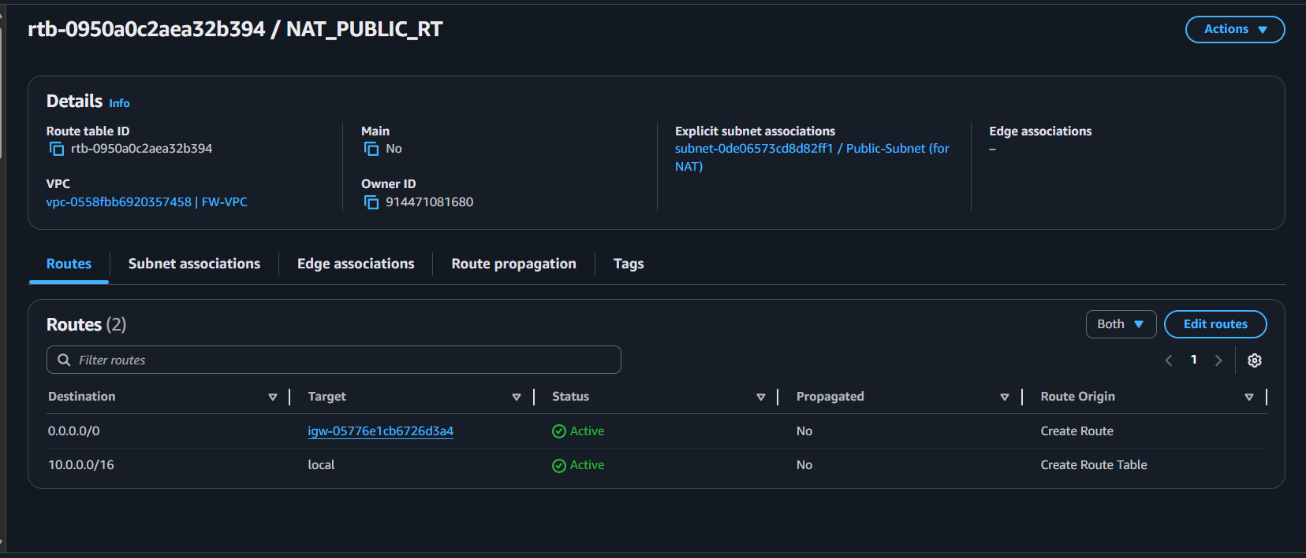
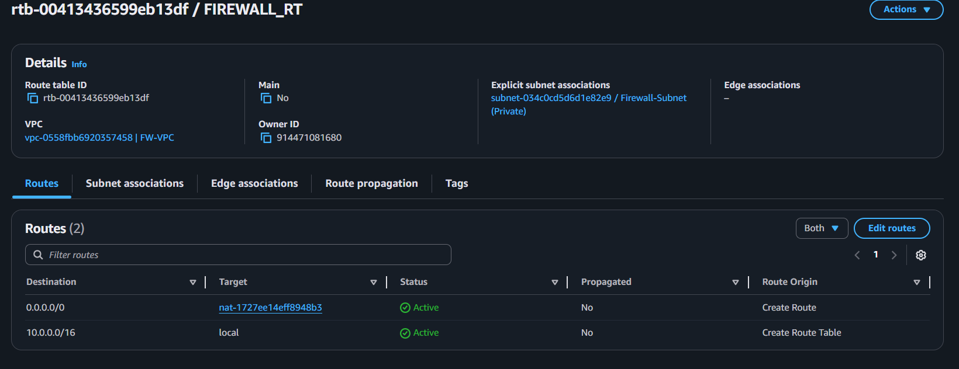
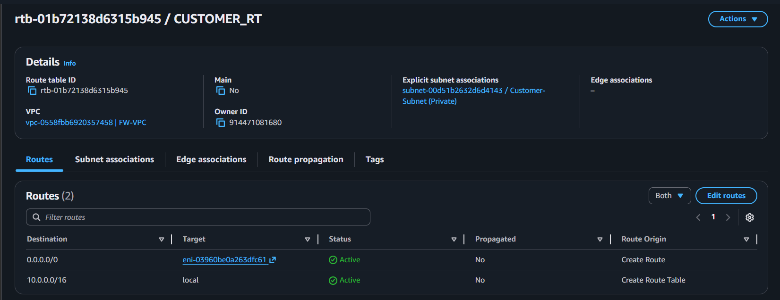

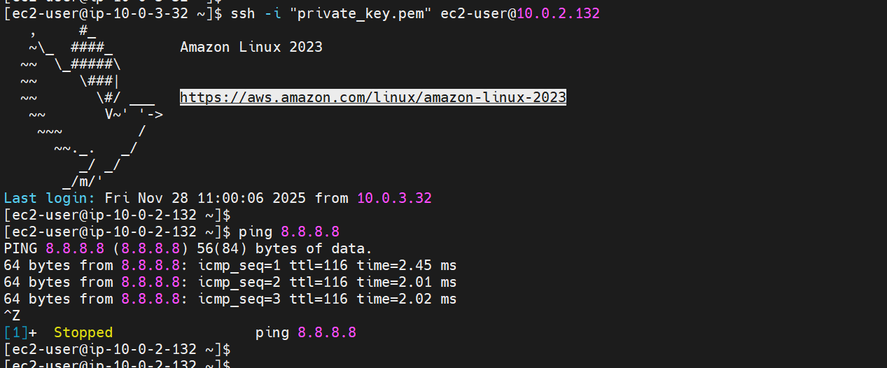
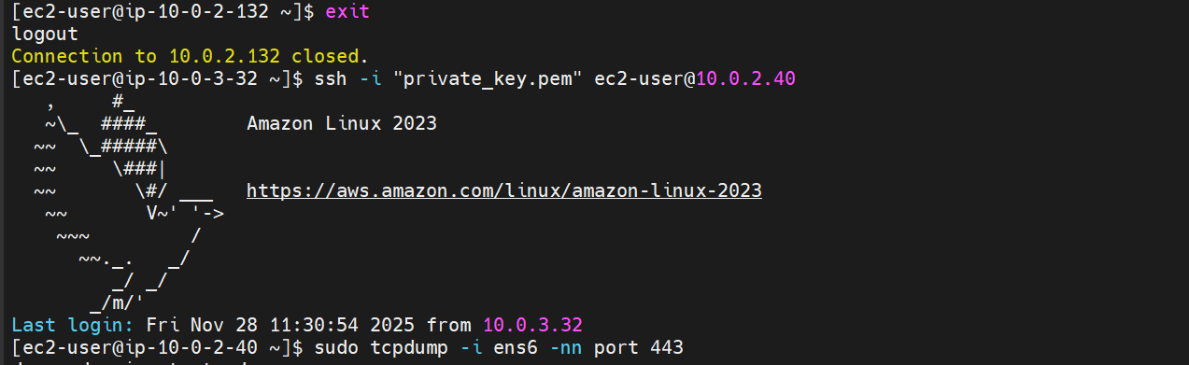
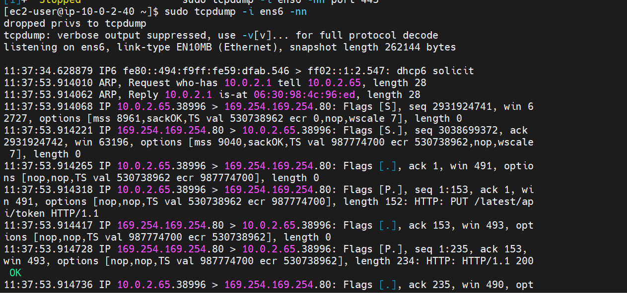
We have placed a firewall EC2 between the customer subnet and NAT gateway.
All outbound traffic from customer EC2 flows through the firewall’s inside interface (ens5) and exits through the outside interface (ens6).
tcpdump on ens6 confirms that the firewall is inspecting public traffic before it reaches the NAT/internet
Customer EC2 is in a private subnet, and all internet-bound traffic is routed to Firewall-EC2. Firewall NATs traffic on ens6, then passes it to the NAT gateway. tcpdump on ens6 confirms full visibility of public HTTPS and ICMP traffic, proving firewall inspection is working

